Ex No:1

<!-- HTML TAG-->

PROGRAM:

<html>

<p> welcome </p>

<p> welcome to my webpage </p>

</html>

OUTPUT:

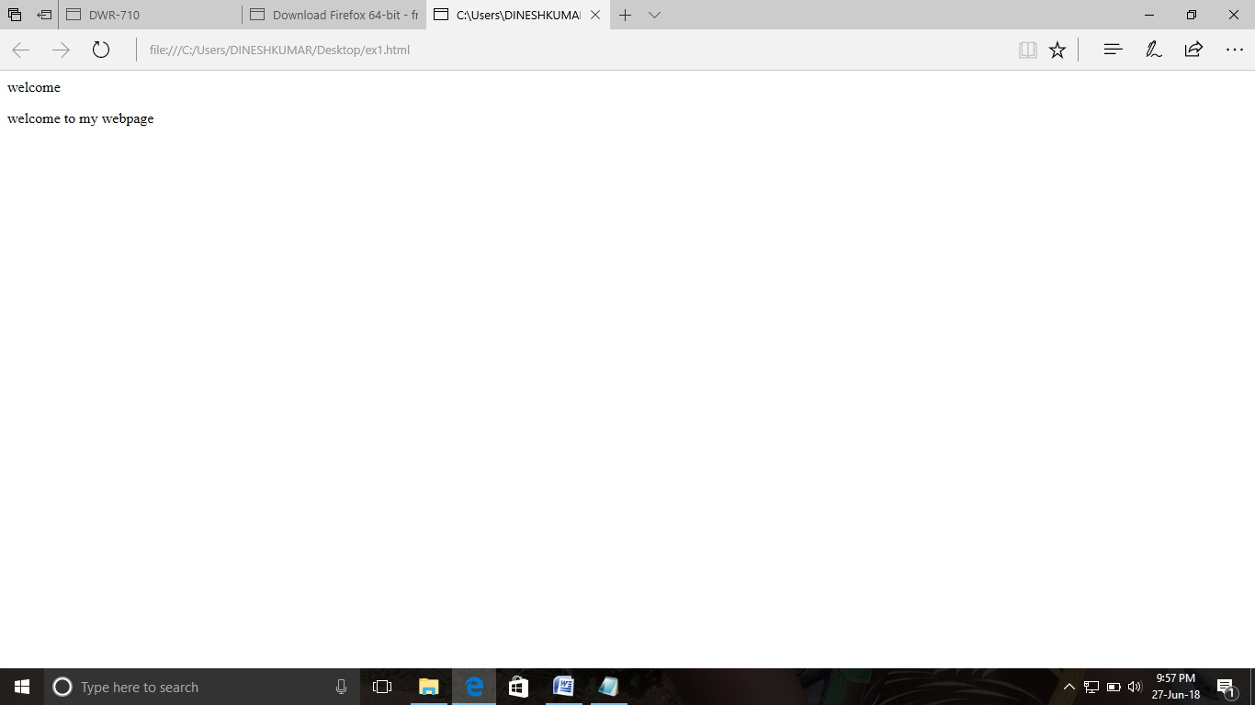

Ex No:2

<!--TITLE TAG-->

PROGRAM:

<html>

<title>

hello

</title>

<p>html is used for designing web pages</p>

</html>

OUTPUT:

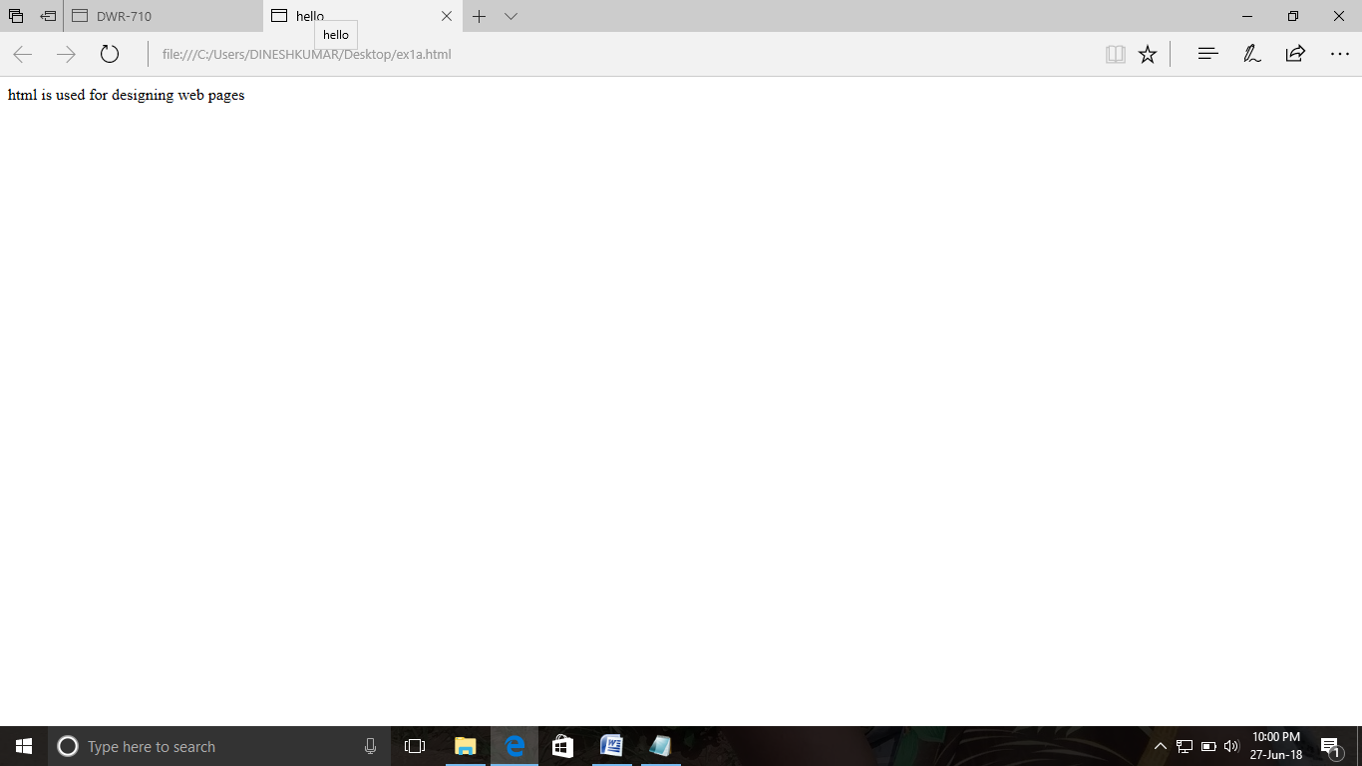

Ex No:3

<!--BODY TAG-->

PROGRAM:

<html>

<body>hello

<p>hi how are you</p>

</body>

</html>

OUTPUT:

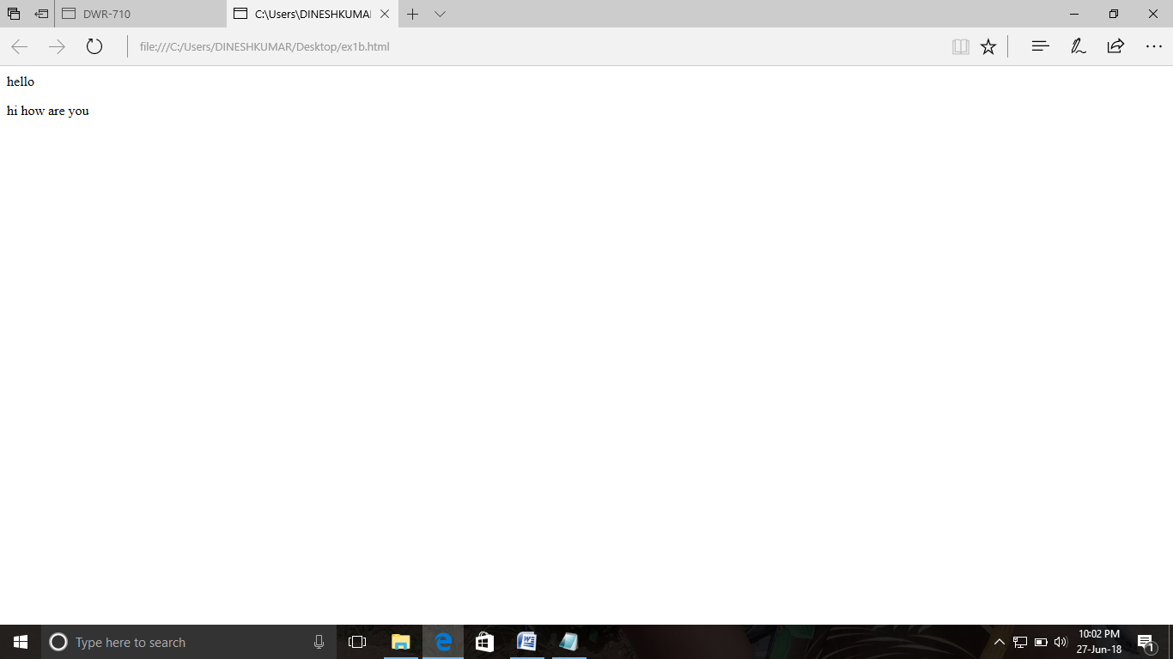

Ex No:4 <!--PARAGRAPH TAG-->

PROGRAM:

<html>

<p><b>WEB TECHNOLOGY</b></p>

<p>paragraph tag</p>

</html>

OUTPUT:

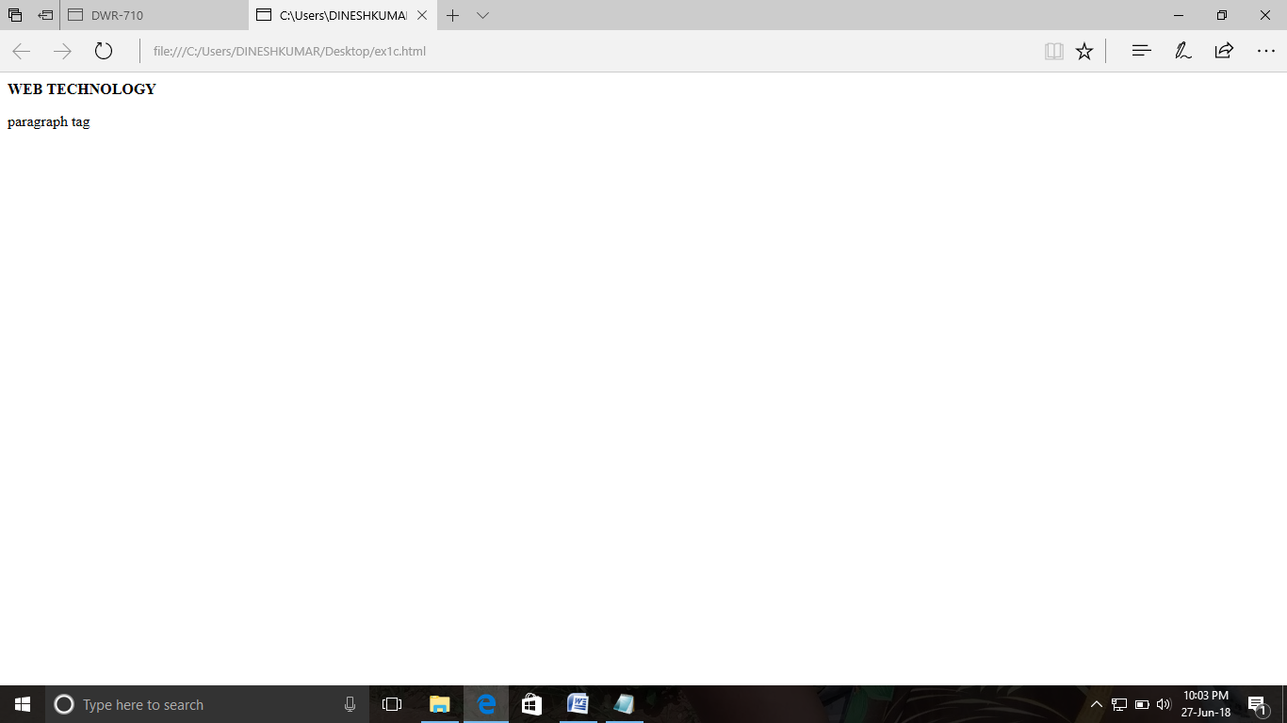

Ex No:5

<!--HEADING TAG-->

PROGRAM:

<html>

<h1>WEB TECHNOLOGY</h1>

<h2>WEB TECHNOLOGY</h2>

<h3>WEB TECHNOLOGY</h3>

<h4>WEB TECHNOLOGY</h4>

<h5>WEB TECHNOLOGY</h5>

<h6>WEB TECHNOLOGY</h6>

<p>hello</p>

</html>

OUTPUT:

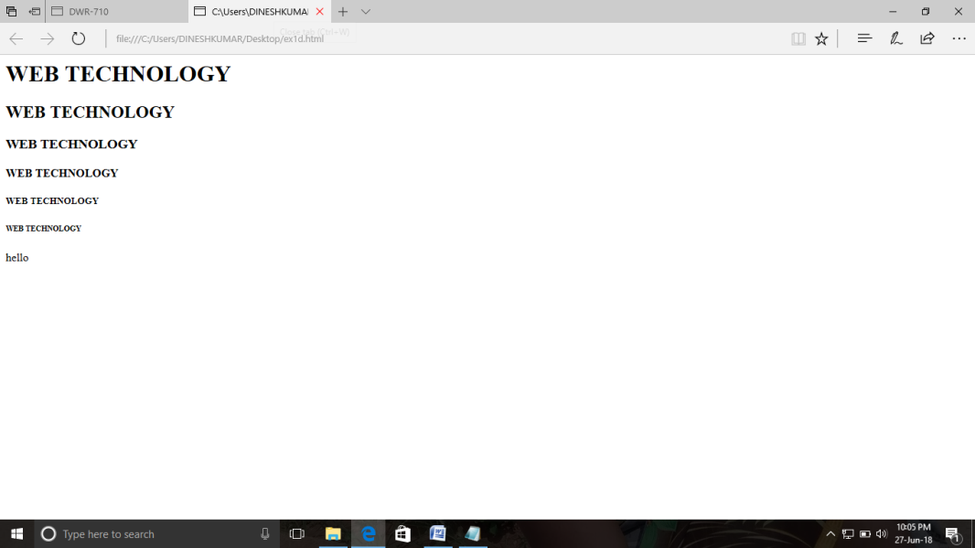

Ex No:6

<!--BOLD ,STRONG,ITALLIC,SUPERSCRIPT,DELETE,CODE TAG-->

PROGRAM:

<html>.

<p><b> my name is dinesh kumar..</b>

<strong>dinesh</strong>

<i>is studying rajalakshmi institute of technology</i>

in 3<sup>rd</sup>

<del>karthi</del>

<code>year student</code></p>

</html>

OUTPUT:

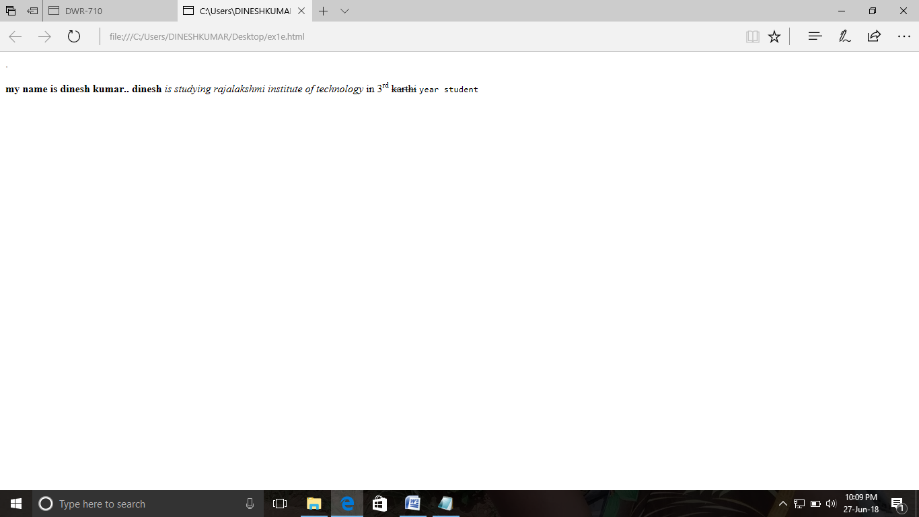

Ex No:7

<!--BREAK LINE TAG-->

PROGRAM:

<html>

<p><b>WEB TECHNOLOGY</b></p>

<p><br>web</br> technology</p>

</html>

OUTPUT:

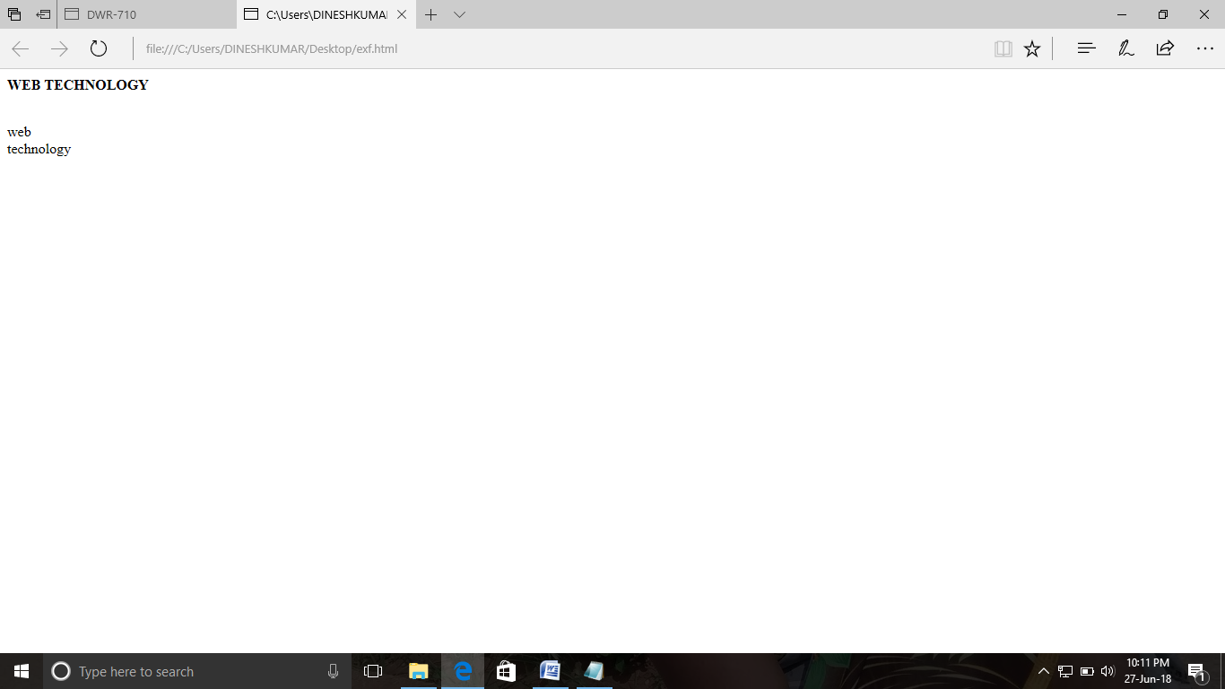

Ex No:8

<!--PRE TAG-->

PROGRAM:

<html>

<p><b> WEB TECHNOLOGY </b><pre>html is used for desingning web pages</pre></p>

</html>

OUTPUT:

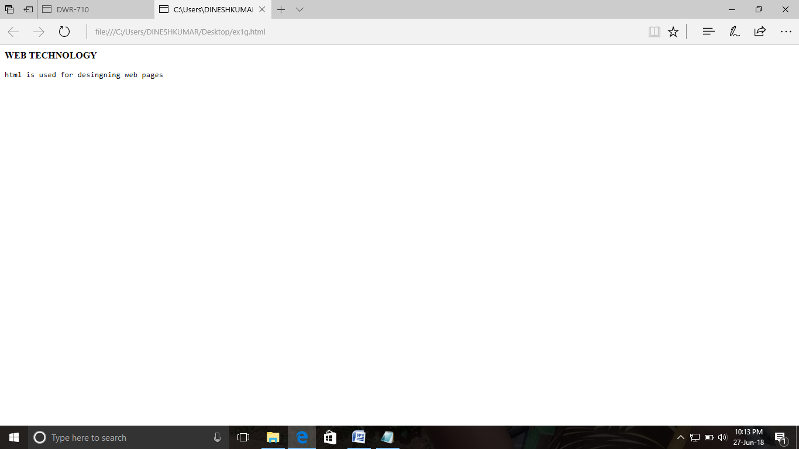

Ex No:9

<!-- TITLE,ALIGN ATTRIBUTE TAG-->

PROGRAM:

<html>

<p><b>WEB TECHNOLOGY</b>

</p>

<body>

<p align="right">html is used for designing web pages</p>

</body>

</html>

OUTPUT:

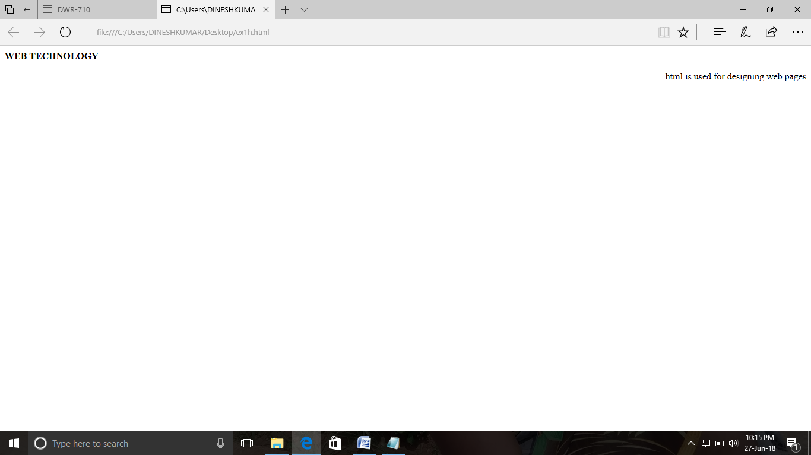

Ex No:10

<!--FONT,SIZE,COLOR,FACE ATTRIBUTE TAG-->

PROGRAM:

<html>

<font size="19" color="red" face="Arial black"><p>hi....java .</p>

</font>

</html>

OUTPUT:

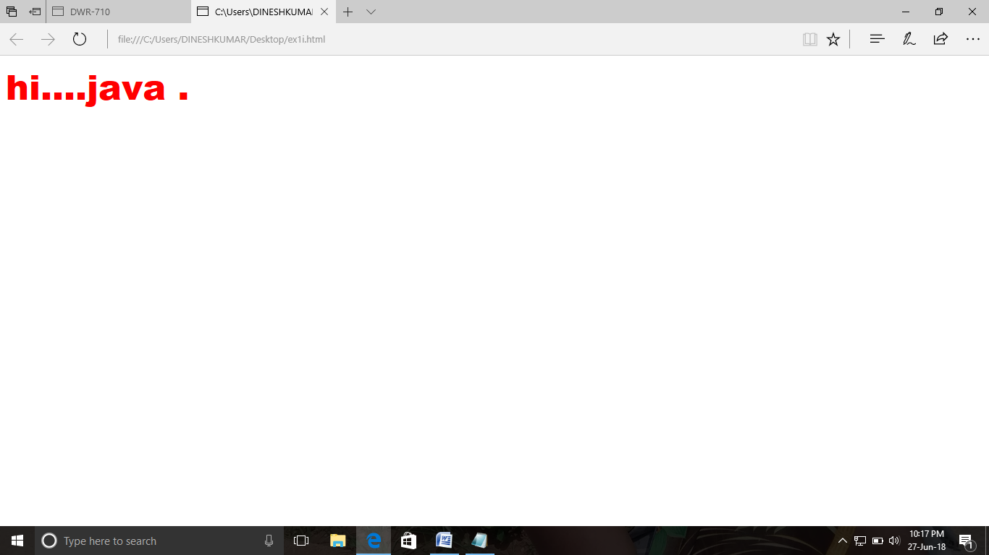

Ex NO:11

<!--HYPERLINK TAG-->

PROGRAM:

<html>

<body>

<a href="http://www.google.com/">google</a>

</body>

</html>

OUTPUT:

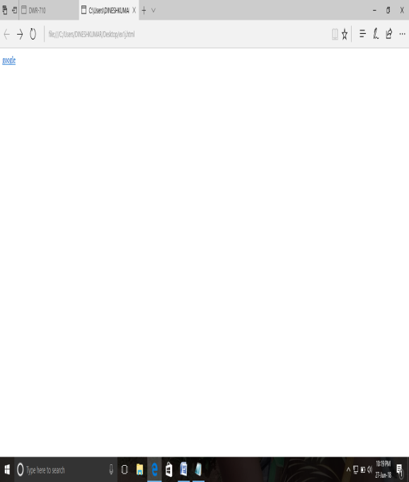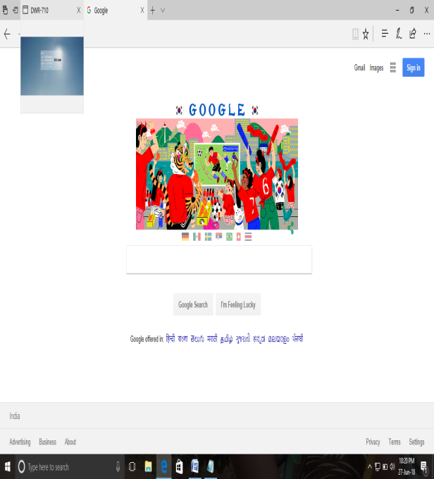

Ex No:12

<!--COMMENT TAG-->

PROGRAM:

<html>

<body>

<comment>comment tag is used in html</command>

</body>

</html>

OUTPUT:

